1.Draw a simple diagram (hand-drawn or digital) showing how your phone connects to Instagram, including your device, WiFi router, ISP, and Instagram server. Label each part and the connections.

->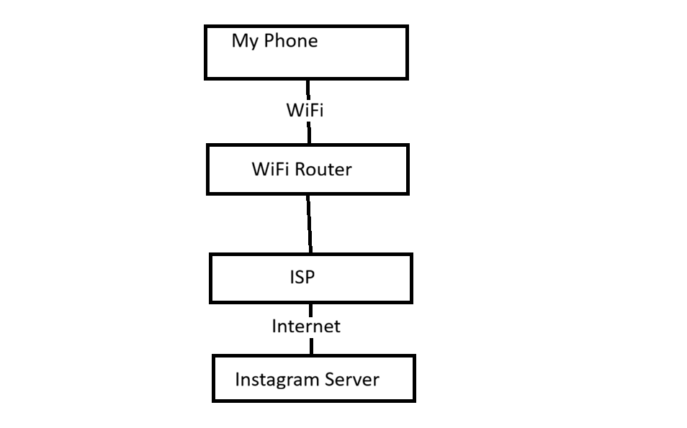
2.List 5 devices you use or see daily that are part of a network (for example: smartphone, smart TV, WiFi router, laptop, smartwatch). For each, write what type of network it connects to (LAN, WAN, PAN, etc.).

->
No. | Device | Network Type
1 | Smartphone | WAN (Mobile Internet), LAN (WiFi)
2 | Laptop | LAN (WiFi)
3 | WiFi Router | LAN
4 | Smart TV | LAN (WiFi)
5 | Smartwatch | PAN (Bluetooth), LAN (WiFi)

3.Explain the difference between the Internet and an intranet using an example from your college or a public WiFi you have used.

->Difference Between Internet and Intranet
Internet:
Internet is a public network.
Anyone can use it.
Example: When I use my phone with Jio/Airtel data or public WiFi to open Instagram or YouTube, I am using the Internet.

Intranet:
Intranet is a private network.
Only authorized users can access it.
Example: In my college, the computer lab network is an intranet. Students and staff can access only the college resources.

Difference:
Internet → Public network, used by everyone.
Intranet → Private network, used only within an organization like a college or company.

4.Pick any one app you use (like WhatsApp, Zomato, or Flipkart) and describe, in 4-5 lines, how data travels from your device to their server and back when you perform a search inside the app.<br><br><em><strong>Hint:</strong> Mention the devices and networks involved, and what happens when you hit 'search'.</em>
-> App: Instagram
I open Instagram and search for a username.
My phone sends the search request through WiFi or Mobile Data to the ISP and then to the Instagram server.
The server processes the request and finds the matching account.
The result is sent back to my phone and displayed on the screen.

